 

**IBMPROJECT**

GASLEAKAGEMONITORINGANDALERTINGSYSTEMFORINDUSTRIES

**Batch:**B5-51ME

**Team ID:**PNT2022TMID53681

**TeamLeader:**MOHAMED AFSAR

**TeamMembers:**

* KRISHNAVIGNESH R
* NAVEEN BALAJI J
* SRINIVAASH A S

CONTENTS

|  |  |
| --- | --- |
| **TITLE** | **PAGENUMBER** |
| 1.**INTRODUCTION** | 4 |
| a.ProjectOverview | 4 |
| b.Purpose | 4 |
| 2.**LITERATURESURVEY** | 4 |
| a.ExistingProblem | 4 |
| b.References | 4 |
| c.ProblemStatementDeﬁnition | 5 |
| 3.**IDEATION&PROPOSEDSOLUTION** | 5 |
| a.EmpathyMapCanvas | 5 |
| b.Ideation&Brainstorming | 6 |
| c.ProposedSolution | 8 |
| d.ProblemSolutionﬁt | 9 |
| 4.**REQUIREMENT&ANALYSIS** | 10 |
| a.FunctionalRequirement | 10 |
| b.Non-Functionalrequirements | 10 |
| 5.**PROJECT DESIGN** | 11 |
| a.DataFlowDiagrams | 11 |
| b.Solution&TechnicalArchitecture | 11 |
| c.UserStories | 12 |
| 6.**PROJECTPLANNING&SCHEDULING** | 13 |
| a.SprintPlanning&Estimation | 13 |
| b.SprintDeliverySchedule | 13 |
| c.ReportsfromJIRA | 13 |
| 7.**CODING&SOLUTIONING** | 14 |
| a.Feature1 | 14 |
| b.Feature2 | 15 |
| 8.**TESTING** | 15 |
| a.TestCases | 15 |

|  |  |
| --- | --- |
| b.UserAcceptanceTesting | 15 |
| 9.**RESULTS** | 15 |
| a.PerformanceMetrics | 15 |
| 10.**ADVANTAGES&DISADVANTAGES** | 16 |
| 11.**CONCLUSION** | 16 |
| 12.**FUTURESCOPE** | 17 |
| 13.**APPENDIX** | 17 |
| SourceCode | 17 |
| GitHub&ProjectDemoLink | 17 |

# INTRODUCTION

* 1. **ProjectOverview:**

Thisprojecthelpstheindustriesinmonitoringtheemissionofharmfulgases.Inseveralareas,theintegrationofgassensorshelpsinmonitoring

thegasleakage.Ifinanyareagasleakageisdetectedtheadminswillbenotiﬁedalongwiththelocation.Inthewebapplication,adminscanviewthesensorparameters.

# Purpose:

Inhalingconcentratedgascanleadtoasphyxiaandpossible

death.Toovercomethesedisasters,wedesignedasystemformonitoringandalertingtheleakageofthoseharmfulgases.Thismakestheindustrialistsgetridofthefearofanydisasterscausedbythegases.

# LITERATURESURVEY

* 1. **Existing Problem:**

This scheme is meant to fulﬁll the daily needs of the people.In our country 40 percent people die due to gas explosion at home. That number keepsgrowing. Even pregnant women and small children are affected.Using a GSM moduleandamobilephone,theGasLeakageMonitorisusedtoﬁnd,intimateleaks.ThebuzzerandLEDarethenactivatedafterthegasleakisdetectedusingabracketsensor.When

thedesignatedtimehaspassed,itwillautomaticallyturnoff.

# References:

* + 1. ShitalImade,PriyankaRajmane,AishwaryaGavali,V.N.Nayakwadi“Review paper on- LPG Gas leakage detection using IOT”: IJIRS –International Journal ofInnovativeResearch&Studies,Volume8,Issue2,Feb2018IJIRS:ISSNNO:2319-9725.[2]GasLeakage Detection Based on Arduino And Alarm Sound, Rhonnel S. Paculanan, Israel Carino,International Journal of Innovative Technology and Exploring Engineering (IJITEE) Vol 8, April2019.[3]Dr.ChetanaTukkoji,Mr.SanjeevKumar,“Reviewpaperon-LPGGasleakagedetectionusingIOT”:IJEAST–InternationalJournalofEngineeringAppliedScience&Technology,Volume4,Issue12,April2020IJEAST(online):603-609.[4]SanjoyDas,SahanaS,SoujanyaKSwathiMC,"GasleakagedetectionandpreventionusingIoT",InternationalJournalofScientiﬁcResearch% Engineering Trends. Vol 6, Issue 3, May-June 2020, ISSN (online): 2395-566X. [5] AmatulMunnaza, RupaTejaswi, Tarun Kumar Reddy, SarangaMoahan “IoT Based Gas LeakageMonitoring Syste”, Journal of Xi’an University of Architecture &Technology,Vol 12, ISSN No:1006-7930,Issue5,2020.[6]B.F.Alshammari,M.T.Chughtai,“IoTGasleakagedetectorandwarning generator”. Engineering and Technology and Applied Science Research Volume 10,IssueAugust2020.6142-6146.[7]GasLeakageDetectionandPreventionSystem,Shreyas

Thorat, Neha Tonape, International Journal of Trendy Research, Vol 4, Issue 7, Dec 2020, ISSNNO:2582-0958.[8]RohanKH1,NavanikaReddy,PranamyaMaddy,SachitGirish,Dr.BadariNathK “IOT based gas leakage detection and Alerting system”: JRP Publications,Vol. 1(1), pp. 002-006,February2021.[9]D.Surie,O.Laguionie,T.Pederson,“Wirelesssensornetworkingofeverydayobjectsinasmarthomeenvironment”,ProceedingsoftheInternationalConferenceonIntelligent Sensors”, Sensor Networks and Information ProcessingISSNIP- 2008, pp. 189 – 194.REFERENCE: [10] J. Tsado, O. Imoru, S.O. Olayemi, “Design and construction of a GSM basedgasleakAlertsystem”‖,IEEETransaction,IRJEEEVol.1(1),pp.002-006,September,2014.[11]

M.Eisenhauer,P.Rosengren,P.Antolin,“ADevelopmentPlatformforIntegratingWirelessDevices and Sensors into Ambient Intelligence Systems”, pp.1- 3. [12] HarshadaNavale, Prof.B.V.Pawar,“ArmBasedGasMonitoringSystem”.InternationalJournalofScientiﬁc&Technology Research Volu me 3, Issue 6, June 2014. [13] ByeongkwanKang,SunghoiPark,Tacklim LeeandSehyun Park, "loTbased Monitoring System using Tri-level Context Making Model for SmartHomeServices",2015IEEEInternationalConferenceonConsumerElectronics(ICCE),2015.[14]Abhishek,P.Bharath,“Automationoflpgcylinderbookingandleakgemonitoringsystem,”InternationalJournalofCombinedResearchandDevelopment(IJCRD),pp.693–695,2016

# Problem statement deﬁnition:

This device does not get damaged very quickly, and if itdoes get damaged, water is the main reason for it. This device is easily damaged by water.Therefore,thisdeviceshouldbeinstalledinaplacewherewaterdoesnotgo.Thisinstallationwillnotdamagethedevice,ifthedevicedoes,anexampleiswater.

This tool is considered to be one and very safe for the users. Mymembers are trusted. My members' invention is considered very safe for this country and itspeople and their families. Absence of this tool makes women in our country nervous by thespreadofgasintheirkitchenandisconsideredtobeasignofsomeaccident.Itisalsoproudtothinkofthisprojectforpeople'slivesonlytoeliminatethisfear.

# IDEATION &PROPOSED SOLUTION:

* 1. **EmpathyMapCanvas:**

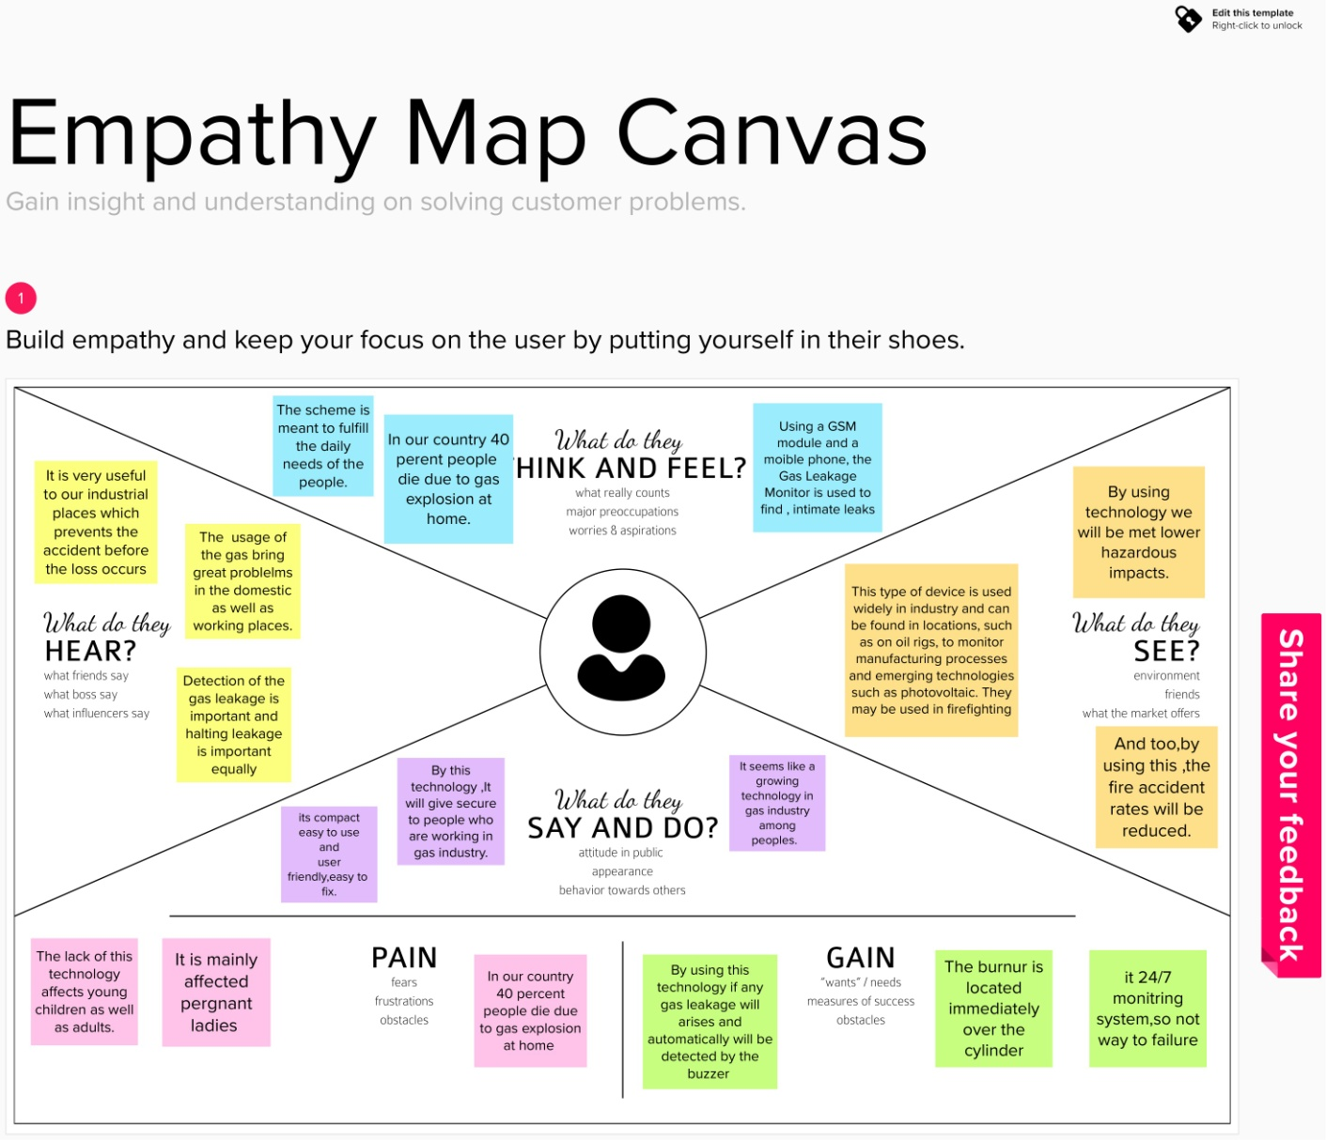

# Ideation&Brainstorming:

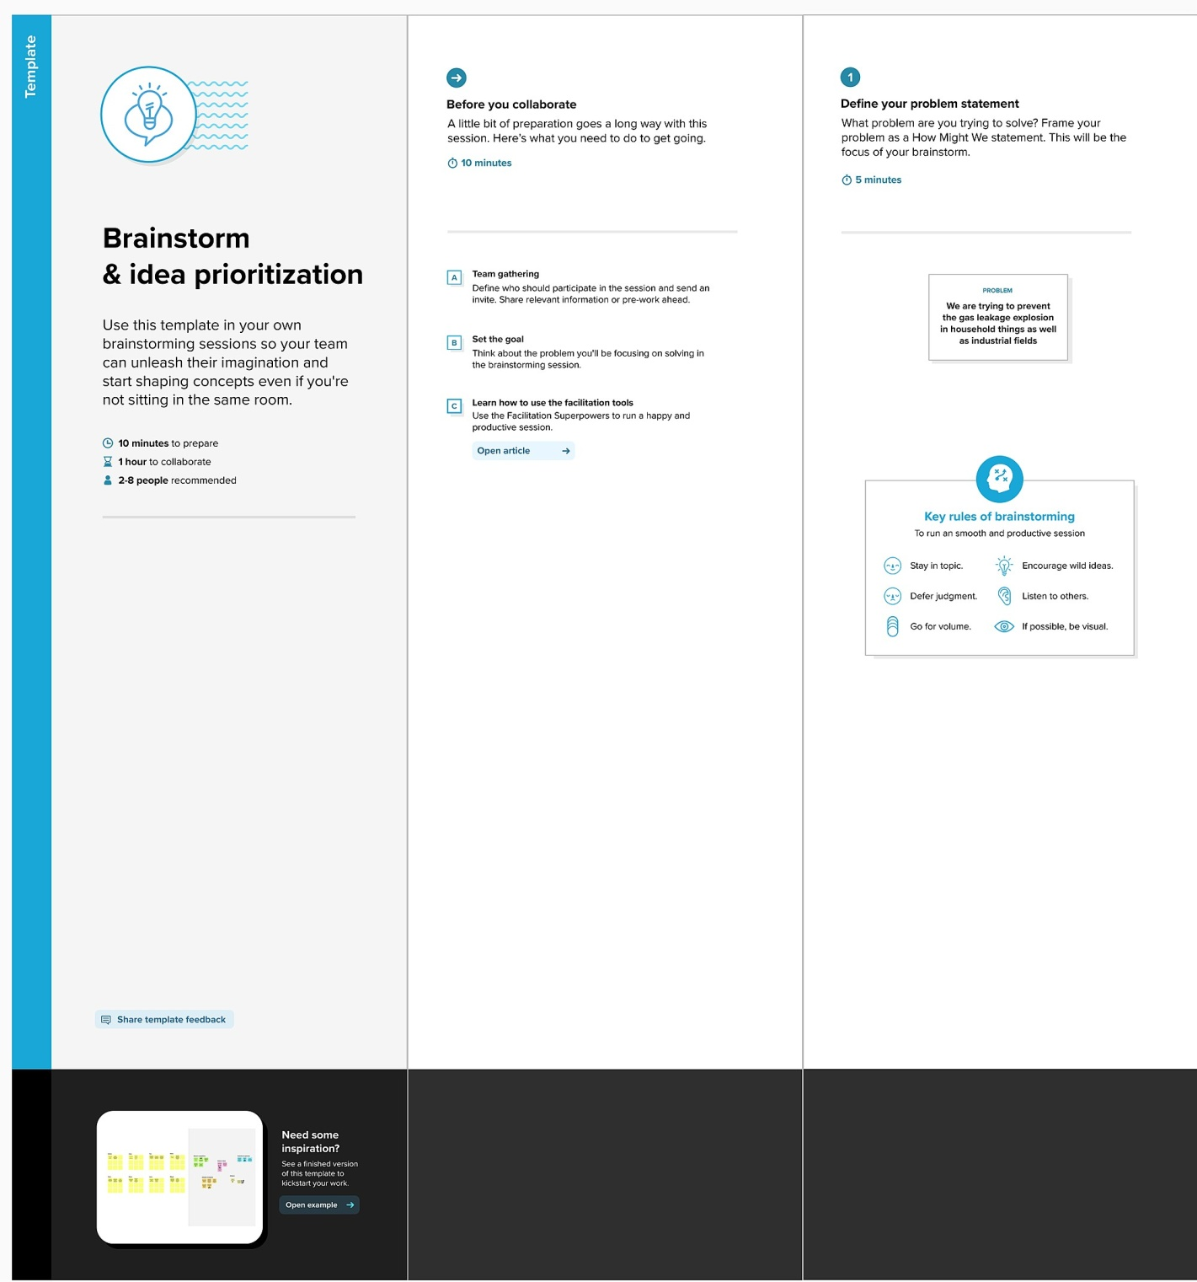

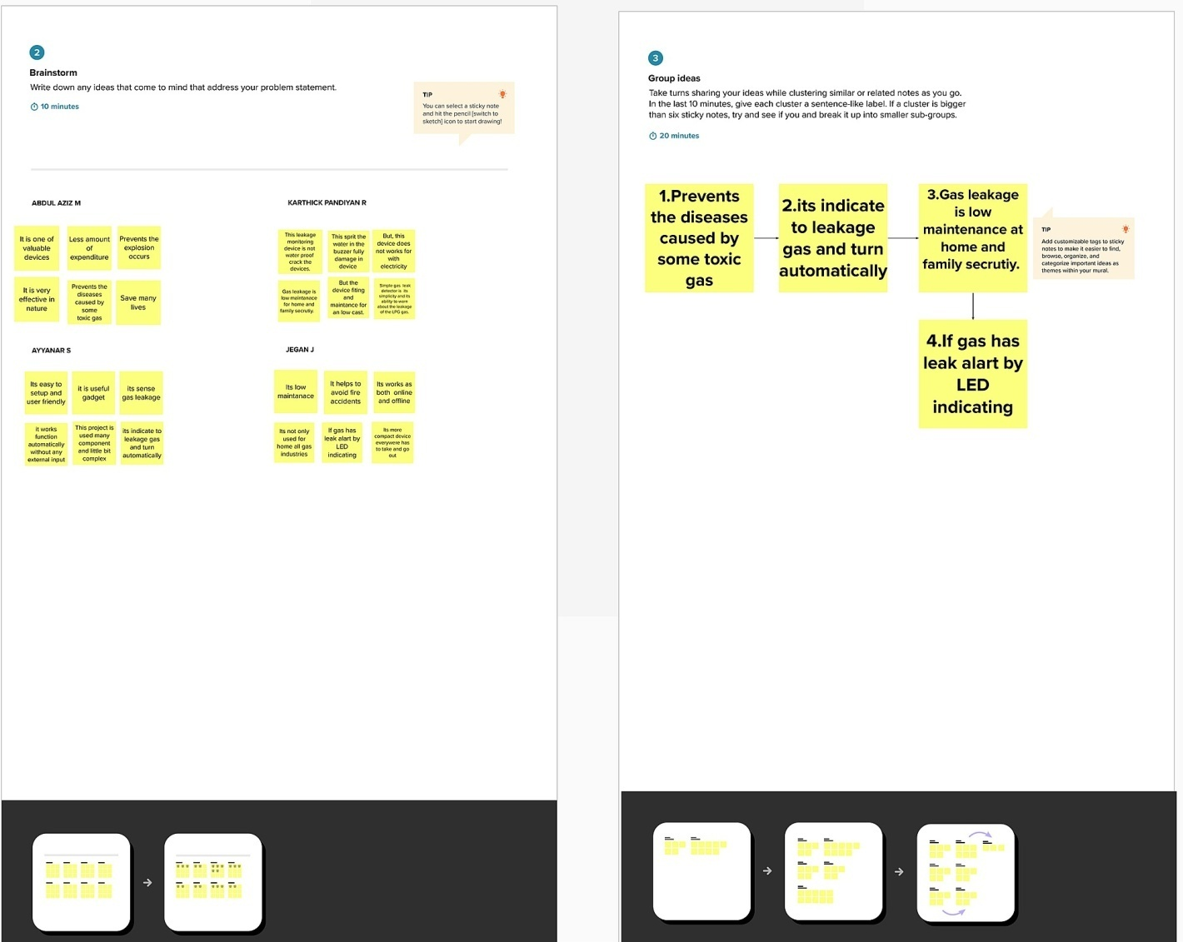

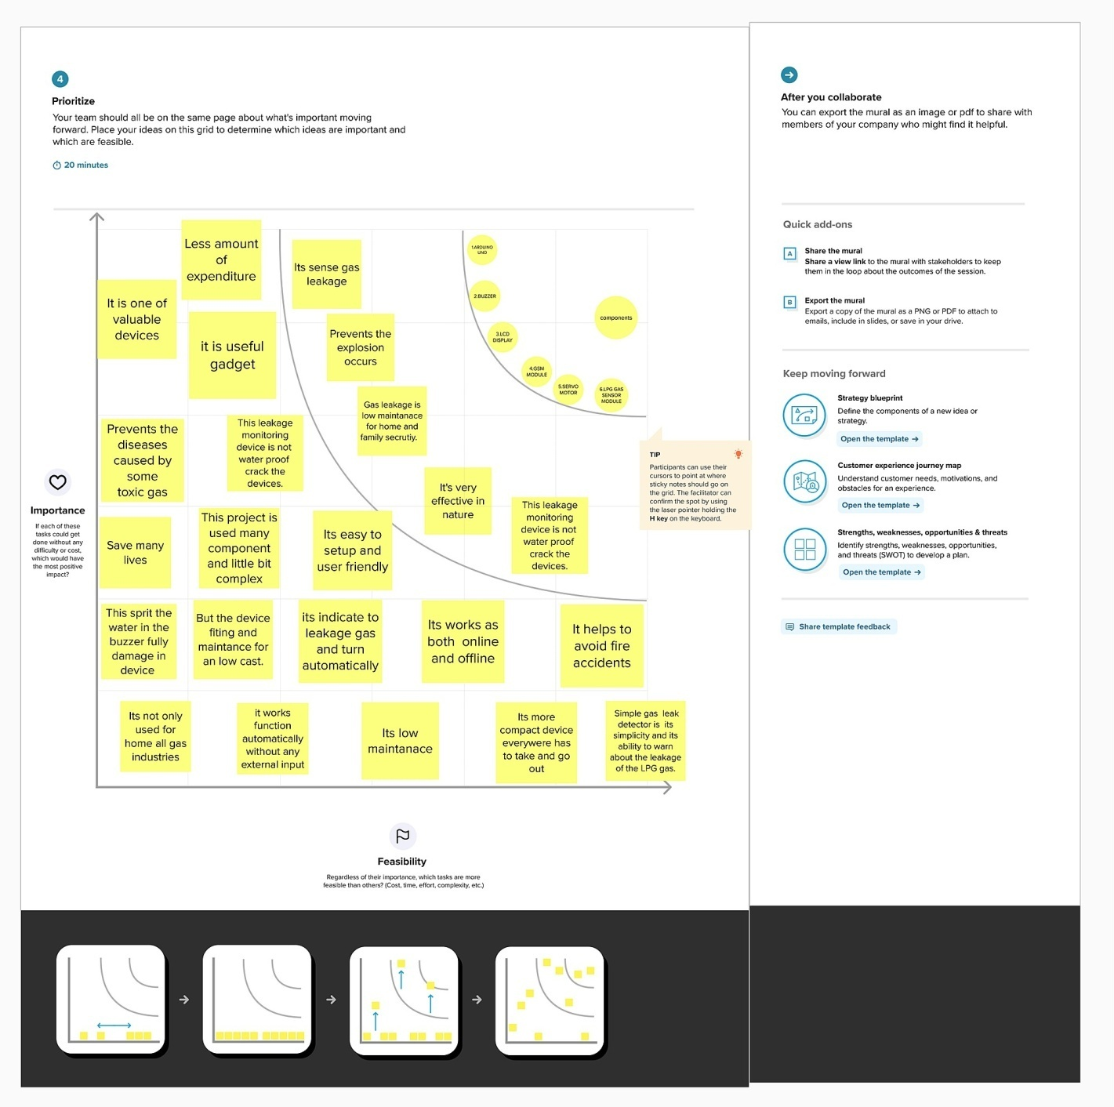

**ProposedSolution:**

|  |  |  |
| --- | --- | --- |
| **S.NO** | **Parameter** | **Description** |
| **1.** | ProblemStatement  (Problemtobesolved) | This monitoring is used toprevent ﬁre accidents dueﬂammable gas leakage inhouse fromcylinders,industries,hospitals,  hotelsetc. |
| **2.** | Idea/Solutiondescription | This monitoring system usescloud and iot based hardwares and sensors.Thesensorsinthesystemdetectsﬂammable gaseouscomponents in theenvironment and temperatureusing iot system and sendindicationviaalarmsand  lights. |
| **3.** | Novelty/Uniqueness | The uniqueness of thissystem is that it uses cloudduetothis,thealarmcanbeto the person via sms to hismobilewhenheisnotin  home. |
| **4.** | SocialImpact/CustomerSatisfaction | It helps in many ways to thesociety it prevents ﬁreaccidents due carelesshandle of gas cylinders . thisisareal-timesystemssoitisfasterandaccidentscanbe  preventedveryeasily. |
| **5.** | BusinessModel(RevenueModel) | This is a cloud based realtimesystem,thatcollectsthedata from the environmentvery quickly i.e.temperature,humidityand  oxygencomposition.using |

|  |  |  |
| --- | --- | --- |
|  |  | sensorsandindicatevia  alarmsandlights. |
| **6.** | ScalabilityoftheSolution | Accuracy.  Lowcost.  Lessmaintenance.  Reliability. |

# ProblemSolutionFit:

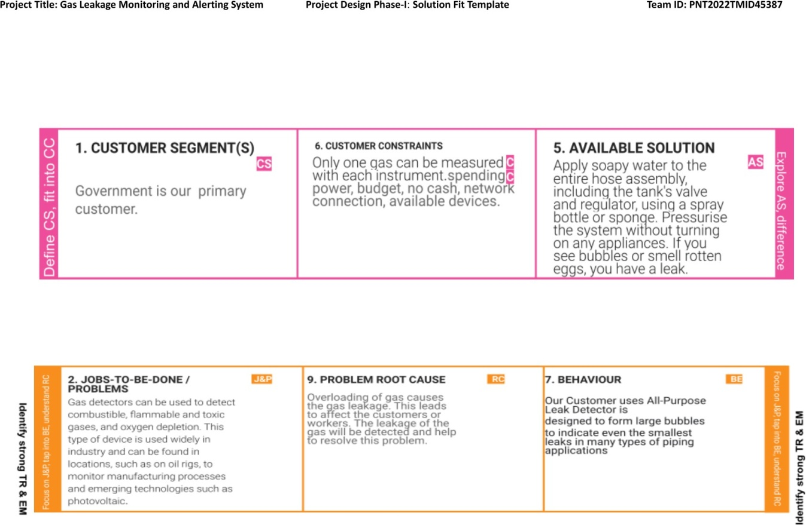

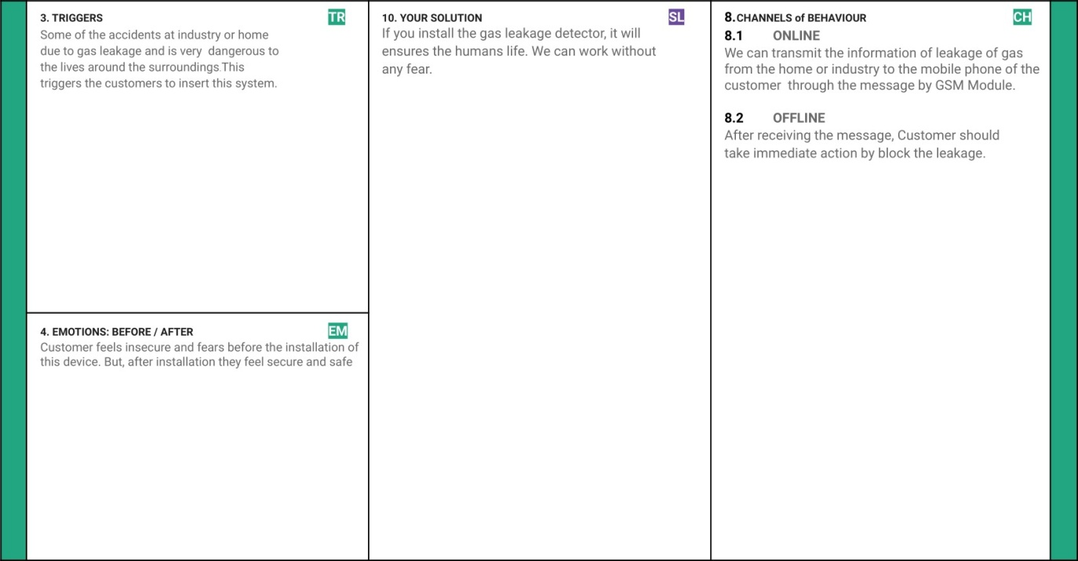

**5.REQUIREMENTANALYSIS**

# FunctionalRequirement:

|  |  |  |
| --- | --- | --- |
| **FRNo.** | **FunctionalRequirement**  **(EPIC)** | **SubRequirement(Story/**  **Sub-Task)** |
| FR-1 | Createcloudaccount | RegistrationthroughForm  RegistrationthroughGmailRegistrationthroughLink |
| FR-2 | UserConﬁrmation | ConﬁrmationviaEmail  ConﬁrmationviaOT |
| FR-3 | UserLogin | UserLoginViaMailidAnd  Password |
| FR-4 | Cloudregistration | Connectthehardwaredevice |
| FR-5 | Connecttomobile | Connectthecloudwiththe  mobilephone |
| FR-6 | ConnectHardware | Connecthardwaretothegas  cylindersorinthewall |

**Non-functionalRequirements:**

|  |  |  |
| --- | --- | --- |
| **FRNo.** | **Non-Functional**  **Requirement** | **Description** |
| NFR-1 | Usability | * Itisuserfriendly * Easytohandle * Processissimple |
| NFR-2 | Security | * Thedeviceishighlysecure. * Privacyismaintained |
| NFR-3 | Reliability | * Thedeviceismorereliable * Thedeviceismoretrustableintough   conditions |
| NFR-4 | Performance | * Theperformanceismoreaccurate. * Itisarealtime   application |
| NFR-5 | Availability | * Itcanbeavailableeasily. * Itrequiresveryfewhardware   components. |
| NFR-6 | Scalability | * Lessmaintenance. * Lowcost. * Compact. |

# PROJECTDESIGN:

**DataFlowDiagrams:**

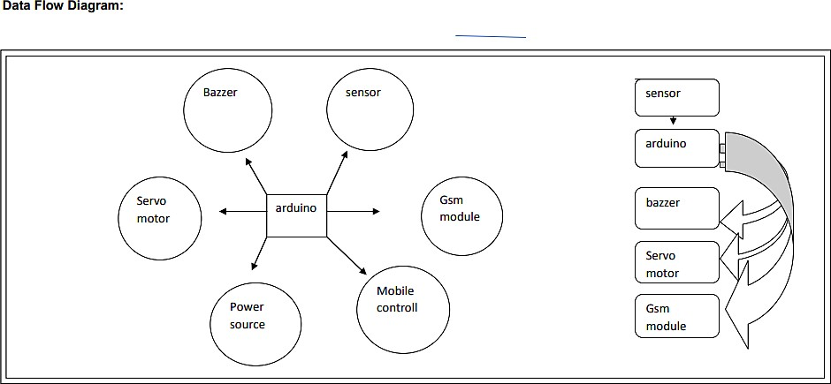

# Solution&TechnicalArchitecture:

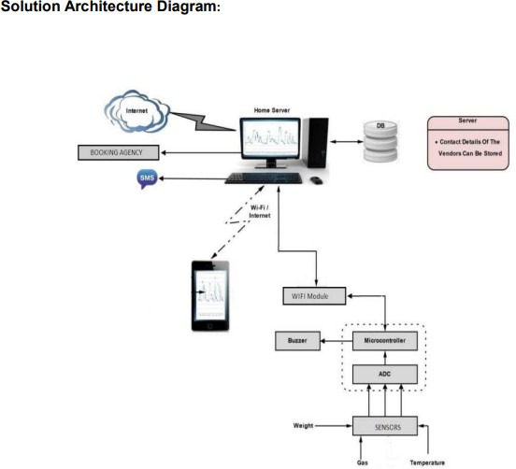

**USER STORIES :**

|  |  |  |  |  |  |  |
| --- | --- | --- | --- | --- | --- | --- |
| **UserType** | **FunctionalRequirement**  **(Epic)** | **UserStory**  **Number** | **UserStory/Task** | **Acceptancecriteria** | **Priority** | **Release** |
| Customer  (Mobileuser) | Registration | USN-1 | Asauser,Icanregister for theapplicationby  enteringmyemail,password, andconﬁrmingmy  password. | I can accessmyaccount/dashboard | High | Sprint-1 |
|  |  | USN-2 | Asauser,Iwillreceive  conﬁrmation emailonceIhave  registeredforthe  application | I can receiveconﬁrmationemail & clickconﬁrm | High | Sprint-1 |
|  |  | USN-3 | Asauser,Icanregister for theapplication  throughFacebook | I can register &access thedashboardwith  FacebookLogin | High | Sprint-2 |
|  |  | USN-4 | Asauser,Icanregister for theapplication  throughGmail | Icanaccessbymessage | Medium | Sprint-1 |
|  | Login | USN-5 | As a user, I can logintotheapplicationbyenteringemail&  password | No need tologinmailid | High | Sprint-1 |
| Customer(Web  user) | Dashboard |  |  |  |  |  |
| Customer CareExecutive | Registeraion | USN-1 | User want to usesimcardandgsmmodule | Messagereciver forarduino  connectedsim | High | Sprint-1 |
|  |  | USN-1 | Sensorand  module | Allcomponent  isconnectedto | High | Sprint-1 |

|  |  |  |  |  |  |  |
| --- | --- | --- | --- | --- | --- | --- |
|  |  |  |  | arduino |  |  |
| Administrator | DATA | USN-1 | What is Maincomponentinthis  project | Arduino | High | Sprint-2 |
|  |  |  |  |  |  |  |
| power | Dc | USN-1 | Howmuchpower  isrequired | 9visenff | High | Sprint-1 |
|  |  |  |  |  |  |  |

# 6.PROJECTPLANNINGANDSCHEDULING:

**SprintPlanning&Estimation:**

|  |  |  |  |  |  |  |
| --- | --- | --- | --- | --- | --- | --- |
| **Sprint** | **FunctionalRequirement**  **(Epic)** | **UserStory**  **Number** | **UserStory/**  **Task** | **Story**  **Points** | **Priority** | **TeamMembers** |
| Sprint-1 | DataPreparation&DataVisualization | USN-1 | As a user, IprovideSafetyto  thecustomers | 5 | High | KarthickpandiyanR |
| Sprint-1 |  | USN-2 | As an Analyst, Icollectthedata&Providemeaningfulinsightsthrough  IBMCloud | 3 | High | JeganJ |
| Sprint-2 | Dashboard | USN-3 | Asauser,Iwant  to make sure thesafeenvironment. | 3 | High | AyyanarS |
| Sprint-2 |  | USN-4 | As an Analyst, Iwill upload thedatainIBMCloudto createainteractive  dashboard | 3 | Medium | AbdulAzizM |
| Sprint-3 | Report | USN-5 | As a user, I wanttosecurethelives  anddataofeach | 3 | Medium | KarthickpandiyanR |

|  |  |  |  |  |  |  |
| --- | --- | --- | --- | --- | --- | --- |
|  |  |  | employee thatreportaparticular  event |  |  |  |
| Sprint-3 |  | USN-6 | As an Analyst, IwilluseIBMCloudtogeneratea  report | 3 | Medium | JeganJ |
| Sprint-4 | Story | USN-7 | As a user, I canonlyunderstandthe Analysis inanimatedpresentationof  dataset | 5 | Medium | AyyanarS |
| Sprint-4 |  | USN-8 | As an Analyst, IuseIBMtocreatean animatedpresentation(Story)ofthe  dataset | 3 | High | AbdulAzizM |

# SprintDeliverySchedule:

|  |  |  |  |  |  |  |
| --- | --- | --- | --- | --- | --- | --- |
| Sprint | TotalStoryPoints | Duration | SprintStartDate | Sprint EndDate(Planned) | StoryPointsCompleted(as onPlannedEnd  Date) | SprintReleaseDate(Actual) |
| Sprint-1 | 5 | 6Days | 24Oct2022 | 24Oct2022 | 5 | 29Oct2022 |
| Sprint-2 | 5 | 6Days | 31Oct2022 | 05Nov2022 | 5 | 05Nov2022 |
| Sprint-3 | 5 | 6Days | 07Nov2022 | 12Nov2022 | 5 | 12Nov2022 |
| Sprint-4 | 5 | 6Days | 14Nov2022 | 19Nov2022 | 5 | 15Nov2022 |

# Velocity:

# We have an 6 day sprint duration and the velocity of the team is 4 (points per sprint).To calculate the the team

# Average velocity(AV) per iteration unit (story points per day).

SPRINTDURATION 6

AV= = = 1.5

VELOCITY 4

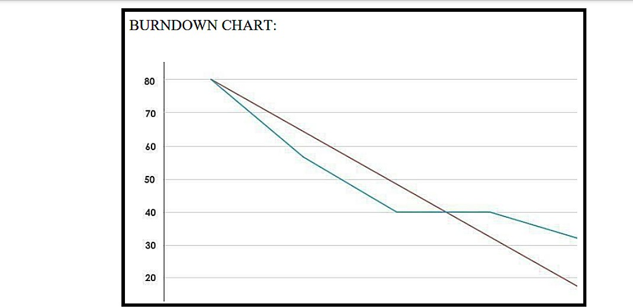

# CODINGANDSOLUTIONING:

* 1. **Feature1(NodeRedOutput)**

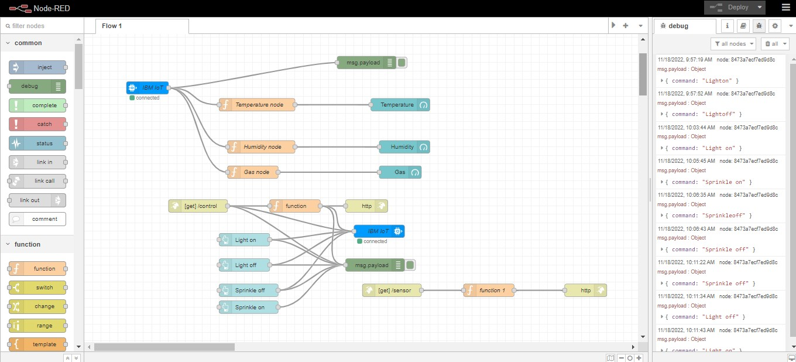

# Feature2:(PythonOutput)

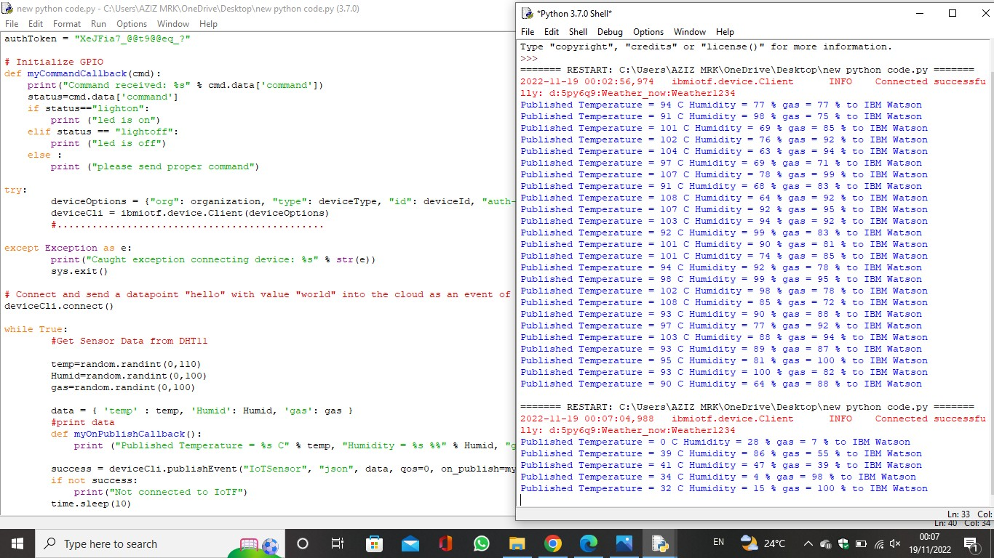

1. **TESTING:**
   1. [**Testcases:**](https://docs.google.com/spreadsheets/d/1-zmHckuq-SKwN2kIEkBfHRJvKKzteVUk/edit#gid%3D583695023)
   2. [**UserAcceptanceTesting**](https://docs.google.com/document/d/1LRCRmq1xSbINhW-MNFTvNolr47A7Sbc0BIKm61DrhHw/edit)**:**

# RESULTS:

* 1. [**PerformanceTesting:**](https://docs.google.com/spreadsheets/d/1NCyGVCh706FDG_GKgtlxa69ms9W-NruA/edit#gid%3D1881962193)

# WEBAPPLICATIONDASHBOARD:

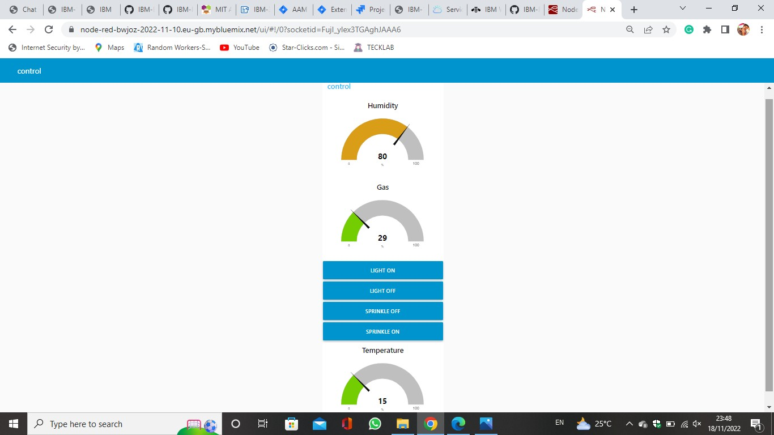

1. **ADVANTAGESANDDISADVANTAGES**

# Advantages:

* Detecttheconcentrationofthegases
* Thesensor-enabledsolutionhelpspreventthehighriskofgasexplosionsandaffectinganycasualtieswithinandoutsidethepremises.
* Getreal-timealertsaboutthegaseouspresenceintheatmosphere
* Preventﬁrehazardsandexplosions
* Ensureworker’shealth
* Real-timeupdatesaboutleakages
* Cost-effectiveinstallation
* Measureoxygenlevelaccuracy
* Getimmediategasleakalerts

# Disadvantage:

* + Getimmediategasleakalerts
  + Whenheavydust,steamorfogblocksthelaserbeam,thesystemwillnotbeabletotakemeasurements

# MOBILEAPPLICATION:

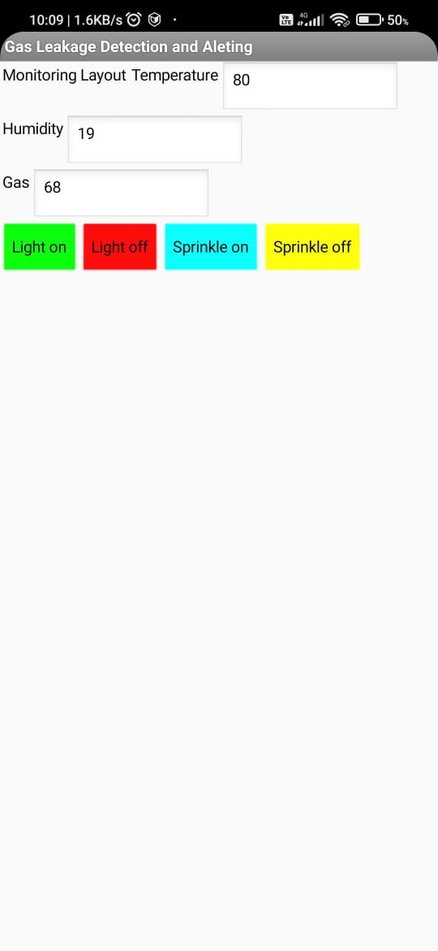

1. **CONCLUSION:**

Gasleakageleadstosevereaccidentsresultinginmateriallossesandhuman injuries.Gas leakage occurs due to poor maintenance of equipment andinadequateawarenessofthepeople.Hence,gasleakagedetectionisessentialto

preventaccidentsandtosavehumanlives.ThispaperpresentedLPGleakagedetectionandalertsystem.Thissystemtriggersbuzzerandnotiﬁcationtoalertpeoplewhengasleakageisdetected.Thissystemisbasicyetreliable.

# FUTURESCOPE:

Major cities of India are pushing Smart Home application, gas monitoringsystemisapartofSmartHomeapplication.EnhancingIndustrialSafetyusingIoT.Thissystem can be implemented in Industries, Hotels and wherever the gas cylinders areused. This system can be used in industries involving applications such as Furnace,Boilers,Gaswelding,Gascutting,SteelPlants,Metallurgicalindustries,FoodprocessingIndustries,GlassIndustries,Plasticindustries,Pharmaceuticals,Aerosolmanufacturing.Ashospitalsrequiretoprovidemaximumpossiblesafetytopatients,thissystemcanbeusedtokeeptrackofallthecylindersusedinit.SomeofthecylindersusedareOxygencylinder,Carbondioxidecylinder,Nitrousoxidecylinder.Asmanystudentsarenaivetherisk of causing accidents is high. Hence, our system can also be used in schools,colleges.Manycollegeshavewellestablishedlabsincludingchemistrylaband

pharmaceuticallabswheregasburnersareused.Severalmedicalequipmentrequiresgascylinders.

# APPENDIX:

**SourceCode:**

**https://github.com/IBM-EPBL/IBM-Project-11348-1659320878/tree/main/Final%20Deliverables/sorce%20code**

**GitHubandProjectDemoLink:**

[**https://github.com/IBM-EPBL/IBM-Project-11348-1659320878**](https://github.com/IBM-EPBL/IBM-Project-11348-1659320878)

**PROJECT DEMO LINK**